
Raffle • Dinner • Networking • Educational Program
Join Us for our upcoming
Chapter Meeting

Wednesday, September 18, 2024
Cannabis As Medicine
This presentation by the New York State Office of Cannabis Management will discuss techniques to educate patients and providers about the science behind the use of Medical Cannabis. Also discussed with be the Office of Cannabis Managements Medical Program, the foundations, how to enroll and resources available to patients and providers.

Speaker
Julien Vincent, Community Liaison,
New York State Office of Cannabis Management

5:15 PM Dinner and Networking • 6:00-7:30 PM Presentation (1.5 CEU’s)

Massapequa Center 101 Louden Ave, Amityville NY 11701

Thank you to our Sponsors
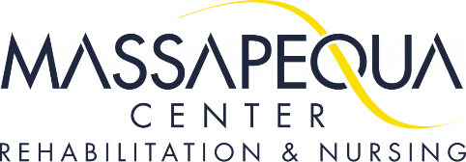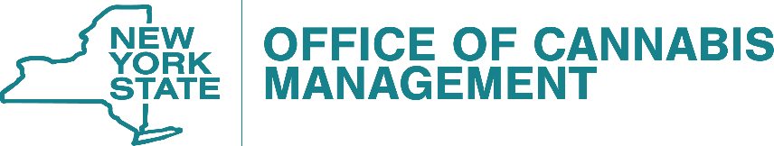

RSVP: September 15, 2024
Register online at www.cmsali.org
NON CMSA MEMBERS $45.00 via PayPal online • WALK INS $50.00
(Members are free BUT need to show proof of active membership) info@cmsali.org
(This program has been submitted for 1.5 CEU’s to the Commission for Case Manager Certification for approval to provide board-certified case managers and the NYS Education Department’s State Board for Social Work as an approved provider of continuing education for licensed social workers #SW-0625)

