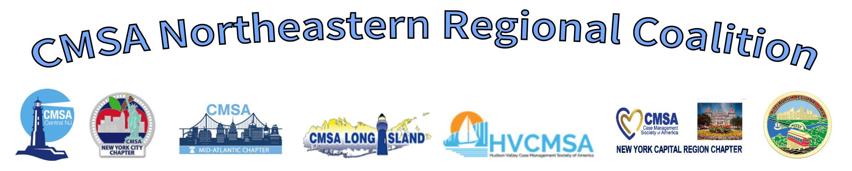

CEU Event: 2.0 CCM with 2.0 CE NY SW Pending

Date:  Time:  Where:  Host Chapter: | February 25th, 2025  6:00-8:00 PM EST (Please dial in 10 to 15 minutes prior to webinar)  Virtual Webinar  
Topic:  Speaker:  Objectives: | National Transitions of Care Coalition (NTOCC) presents: Transitional, Collaborative and Integrative Care Working Together to Deliver Healthcare Services  Cheri Lattimer, RN, BSN, serves as the Executive Director for the National Transitions of Care Coalition (NTOCC) and President/CEO of Integrity Advocacy & Management  - Identify how these care services work together and why patients and family caregivers are looking for a more impactful healthcare experience.  - Review the elements for collaborative care, collaborative agreements and payment models.  - Discuss the GUIDE model and its focus on supporting dementia patients and their family caregivers to remain at home utilizing these models
Sponsored By: | 
Fees and Payment  Registration: | CMSA Members: Free Non-Members $20.00  CMSA Northeastern Regional Coalition: https://cmsanerc.org/
Sorry, there are no refunds or credits for future meetings given in the event that a person is unable to attend.

IMPORTANT INFORMATION:
- We recommend logging into the webinar 10 to 15 minutes prior to the start of the event. This way we can help should any technical issues arise.
- To obtain your CEU Certificate you must attend the entire program. Instructions and survey access code will be provided at the end of the presentation. You must complete the survey in order to receive your CEU certificate.
Be aware once the webinar has started, we are unable to help with technical issues so it is important to sign in 10 to 15 min prior to the event. Any questions?? Feel free to contact us.

